VINH LONG UNIVERSITY OF TECHNOLOGY EDUCATION

**PRACTICE CENTER**

TEST PROJECT

PRACTICAL SKILLS

MODULE 4: IT SOFTWARE SOLUTIONS

MAJORS: SOFTWARE TECHNOLOGY

**Exam Paper Code: ITSS05**

|  |  |
| --- | --- |
| **SCHOOL LEADERSHIP** | **CHIEF SUBCOMMITTEE ON EXAM DEVELOPMENT** |

**Vinh Long, month 12/2020**

**GUIDE CONTESTANTS**

**Module 4: IT Software Solutions**

**Time:**

* Preparation Time: 05 minutes
* Time Duration: 150 minutes
* Break Time: 10 minutes

**Scores:**

|  |  |  |
| --- | --- | --- |
| **Exam content** | | **Marks** |
| 1 | Creating the Database | 5 |
| 2 | Importing Database Structure | 5 |
| 3 | Inventory Dashboard | 50 |
| 4 | Multi-Language Support | 40 |
| **Total Marks** | | **100** |

**Candidates are required to note:**

* Ensure safety standards of health and computer
* Do the test independently without discussing while doing the test
* Comply with regulations of exam room and proctor’s instructions
* Fill the information in the form
* Complete all requirements in the content of the exam
* Do not use documents, the Internet and other communication devices during the assignment
* If the exam does not have special requirement for the file name and storage location, contestants save all exam file name in the folder as following format**: D:\WorkSkills\IT Software Solutions**

***<Student’s Name>_<*** ***Student code >[.<*** ***extension >]***

**CONTENT OF THE TEST**

This Test Project proposal consists of the following documentation/files:

1. ITSS05.pdf (Session instructions)

2. ITSS05-MsSQL.sql (SQL Script to create tables with data for Microsoft SQL)

**INTRODUCTION**

This section of the system will provide a dashboard to the maintenance managers and administrators of Kazan Neft. The dashboard will provide a vital overview of how the inventory is used and where the money is being spent. There’s also an option to select and associate parts to work orders as part of inventory control.

**DESCRIPTION OF TASKS**

While developing the test project, please make sure the deliverables conform to the basic guidelines drawn out by different departments at Kazan Neft:

* There should be consistency in using the provided style guide throughout development.
* All required software modules must have applicable and useful validation and error messages as expected by the industry.
* Offer a scrollbar if the number of records on a list or a table that do not fit in the form area comfortably. Hide scrollbars if all content can comfortably be displayed.
* The de-facto standard, ISO compliant date format is YYYY-MM-DD which will be used in this task where applicable.
* Where applicable, use comments in code to have the code more programmer-readable.
* The use of valid and proper naming conventions is expected in all material submitted.
* Any form or report once created should be displayed in the centre of the screen.
* When a form or a dialogue is in focus, operations on other forms need to be suspended.
* Provide appropriate validation and error messages throughout all parts of the system.
* The caption of Delete and Cancel buttons need to be in red to help with accidental mishaps.
* When using colors to differentiate between rows or records, there needs to be visible clarification on the screen as to what they stand for.
* The wireframe diagrams provided as part of this document are only suggestions and the solution produced does not have to be, in any way, mirror what has been pictured.
* Time management is critical to the success of any project and so it is expected of all deliverables to be complete and operational upon delivery.

**INSTRUCTIONS**

1. **Creating the Database**

Create a database by the name of “ITSS05DATA” in your desired RDBMS Platform (Microsoft SQL Server). This will be the main and only database you will use in this session. In case you are given a database by the same name, you should use the database provided by the administrators.

1. **Importing Database Structure**

Depending on your preferred RDBMS platform, a SQL scripts is made available. The said scripts consist of the database structure and data required to complete the tasks. The data needs to be imported to the database created for this session named “ITSS05”.

As instructed by the designers, the database structure provided for the purpose of this section cannot be altered. This applies to removal of tables, adding or deleting any fields on the tables or of change in their data types.

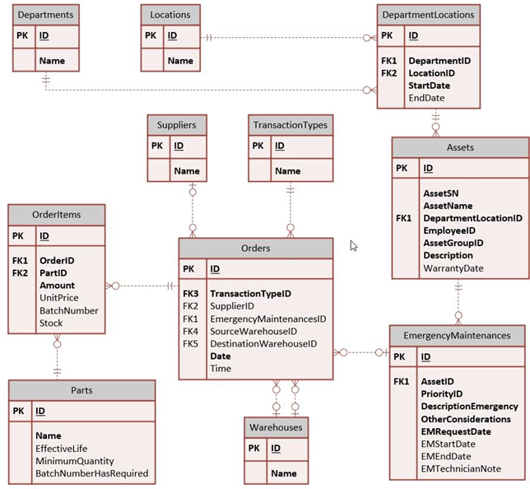

To help further perceive the thinking behind the structure of the database, the database designers provide an Entity-Relationship Diagram (ERD). The aforementioned diagram explains the conceptual and representational model of data used in the database.

1. **Inventory Dashboard**

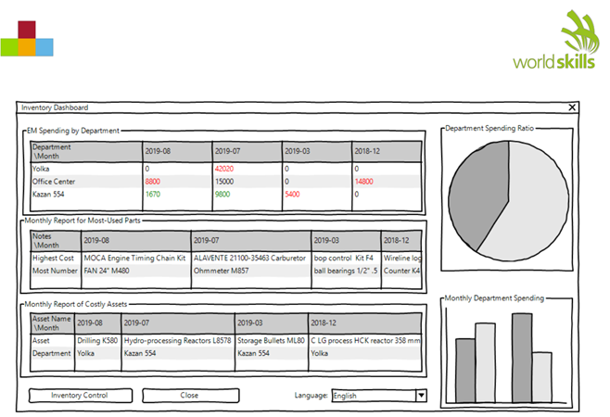

This is the main form for the application that provides an overview or a summary of the inventory used in the maintenance management system. The requested information needs to be displayed in one screen in five sections as described below:

* The first section on the top with the label “EM Spending by Department” shows the monthly expenditure for each department on emergency maintenance requests:
  + - The expenditure is only on parts used as part of EM work orders.
    - Only the months with completed EM work orders should be displayed.
    - The highest and lowest monthly expenditure (non-zero) should be differentiated by colors:
  + Red is suggested for the highest and green for the lowest.
  + If the highest and the lowest are the same, Red can be used to indicate that.
* On the second section, you are asked to create a monthly report for most-used parts for the manager to see where they need to cut costs:
  + - Under “Highest Cost” the user will see what parts have cost the company the most each month.
    - Under “Most Number”, the user needs to see which parts have been used the most each month.
    - Only the months with completed EM work orders should be displayed.
    - If there’s a chance that there are multiple parts that match the criteria, they should be separated by commas.
* On the third section, the manager wants to identify which assets have been costing the company the most each month:
  + - The expenditure on the assets are calculated by summing up the costs of parts used as part of EM work orders completed on the month.
    - The department name should also be displayed below each asset.
    - Only the months with completed EM work orders should be displayed.
    - If there’s a chance that there are multiple assets to be displayed, they should be separated by commas.
* The manager also needs to be able to compare departmental spending on a pie chart:
  + - All the departments with expenditure on parts used over EM work orders should be represented. o Different departments should be set apart by using different colors and labels or a legend.
* As part of the department summary overview, a column chart needs to display how much each month is spent in each of the departments:
  + - All the departments with expenditure on parts used over EM work orders each month should be represented.
    - The column chart should be stacked and each bar should represent a month that has expenditure associated. Proper labels should identify the months.
    - Different departments should be set apart using different colors on each of the columns. Applicable labels or a legend should help the user identify each department.
* The field to use in building the aforementioned reports is “date” from the table “Orders”.
* A button labelled “Inventory Control” will allow the manager control and assign parts to EM work orders.

**4. Multi-Language Support**

The Kazan Neft company employs professionals across the world who speak multiple languages. You are required to implement the following procedure to provide a multi—language interface for the application:

* At the bottom of main form, there’s a drop-down box that lets the user select the language of their choice.
* The translators will provide files in xml format that will be placed inside a folder called “languages” and the application will look for the published languages and include them as choices to the users.
* By default, a file by the name of “default.xml” will be provided for the application to use.
  + - If there are tags or words not found on any of the provided translations, the application will use the definitions on the default file to fill in the empty tags.
* The application has to store and remember the last choice the user makes for future launches.

If the provided file by the translator is faulty, they will not be included in the list.

